28.47: 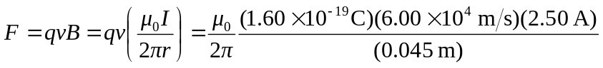
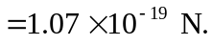

Let the current run left to right, the electron moves in the opposite direction, below the wire, then the magnetic field at the electron is into the page, and the electron feels a force upward, toward the wire, by the right-hand rule (remember the electron is negative).

